ATTACHMENT 1 – WLEP 2009 Zoning Map

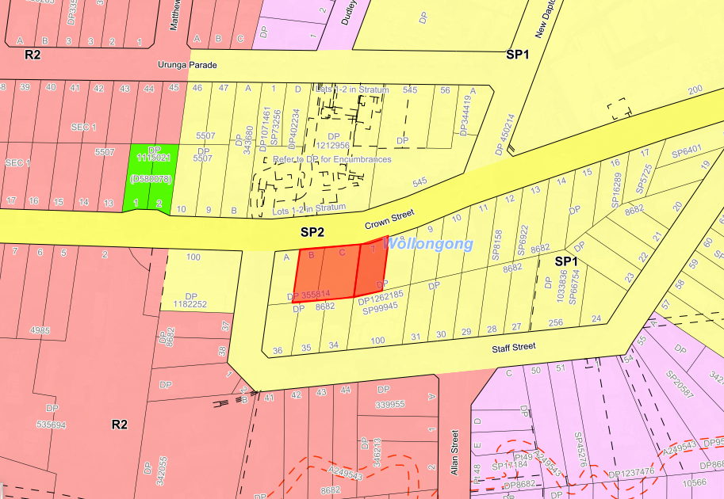

R2 Low Density Residential

